Combine two strings character wise like this

First String : “abcdefg”

Second String : “1234”

Output String : “a1b2c3d4efg”

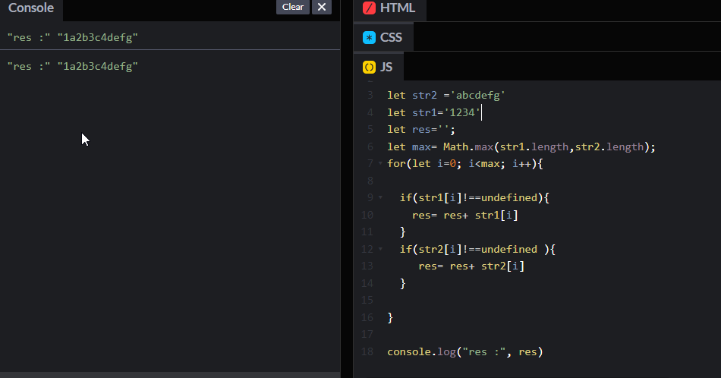

Print Numbers from 1 to 30 in a loop. In the loop, If the number is divisible by 3 , print - A If the number is divisible by 5 , print - B If the number is divisible by 15 , print - AB else print the number

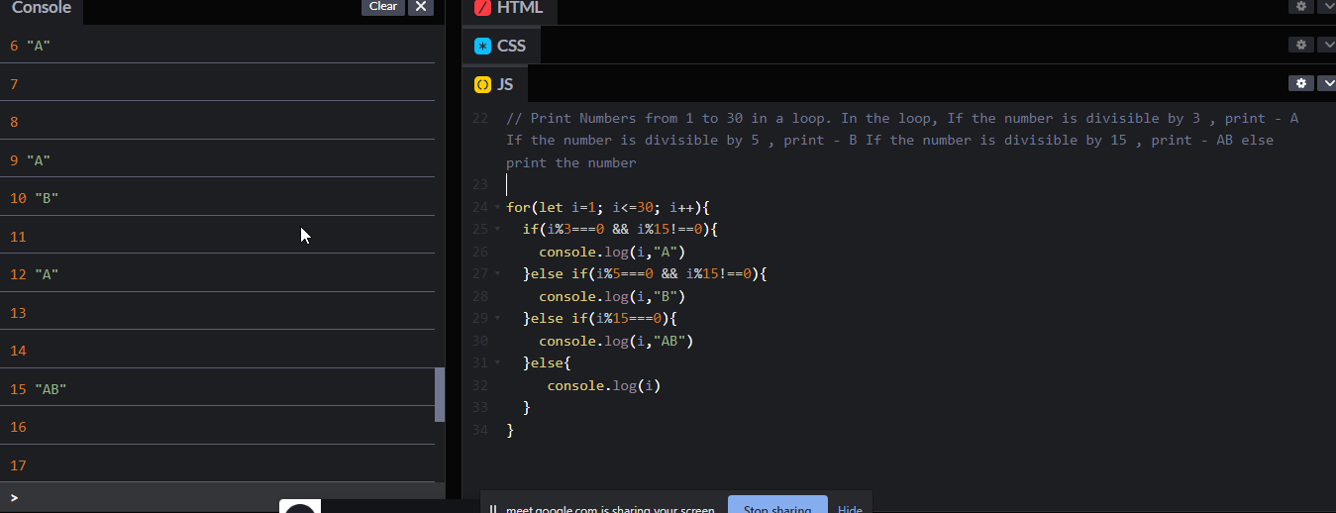

/ Print the pattern

// \*

// \*\*\*

// \*\*\*\*\*

// \*\*\*\*\*\*

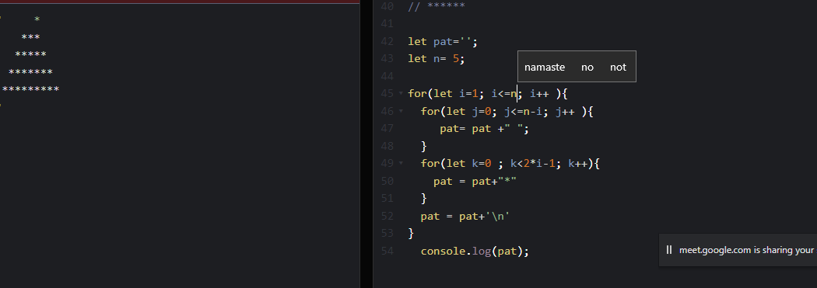

Write a program that takes in an array of integers and returns the sum of all elements in the array that are divisible by 3.

Sample Input: [1, 2, 3, 4, 5, 6, 7, 8, 9]

Sample Output: 18

